Artwork Pipeline
Technical Overview

Revision 0.1
7/18/2003

Copyright 2001-2003 Avalanche Software
Proprietary and Confidential Information
TABLE OF CONTENTS
Introduction 3
Asset Management 3
Artwork Conversion and Processing Tools 3
Attribute Marking and Access Tools 3
General Artist Support Tools 3
ASSET MANAGER 4
User Interface 4
Filter Chain 5
What is Tupperware? 5
What is the Tupperware Graphics Definition? 5
Filter Chain Components 6
Filter Chain Application 6
Filter Chain Configuration File 6
Source Tupperware File 6
Tupperware Memory Data 7
Filters Plugins 7
Image Reader Plugins 8
Attribute Tools 9

Introduction
This document is an overview of tools used in Avalanche Software’s artist pipeline. These tools comprise of the following categories; asset management, artwork conversion and processing tools, attribute marking and access tools, and general artist support tools.

Asset Management
Asset Manager is a proprietary application used for keeping track of the source art files for the company.

Artwork Conversion and Processing Tools
The Filter Chain along with Tupperware export plugins are used for getting the artwork into the engine. These tools rely on the Tupperware file format as well as the Tupperware Graphics Definition. The Filter Chain does its work using filter plugins.

Attribute Marking and Access Tools
Attributes can be marked on the instance, poly faces, and material maps within Maya through the ObjAttrib, FaceAttrib, and MapAttrib plugins respectively. To aid gaining access to these attributes in the Filter Chain as well as in the game engine the TupperAttrib library is used.

General Artist Support Tools
To aid the artists when using Maya the AVATools plugin for Maya was created. Along with several shelves, this plugin provides many needed functions that aid the artists in creating and manipulating their source material.

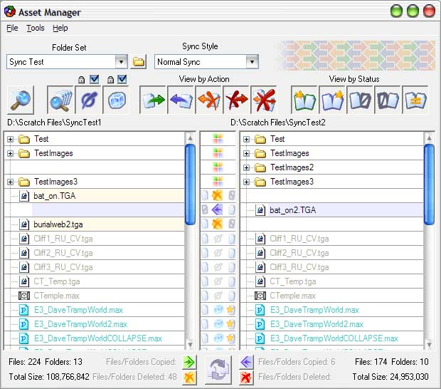
ASSET MANAGER
The Asset Manager application is used for synchronizing files to and from the network. Instead of using a client/server system Asset Manager is simply a glorified file synchronization program. This allows for faster speed for getting files as well as avoiding the problems with having to checking out/in files. A full version control system may be implemented in the future if the need arises. Log files are used to track how the files are added, updated, and deleted. A client database is used for keeping track of the previous state of the system for handling delete propagation. This way when a file is no longer needed on the network it will get deleted from the other machines automatically.

User Interface
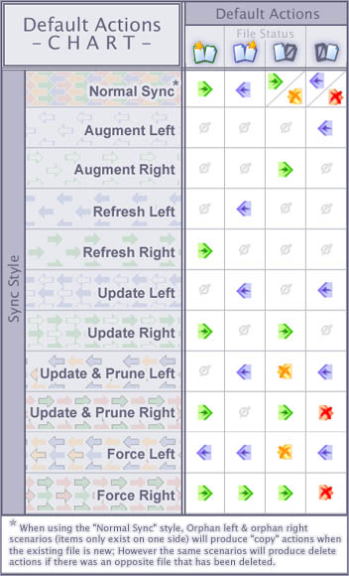
The main portion of the window shows three panels. The left and right panels show the files and the middle panel shows the status of the files as well as what action will be preformed when syncing. Files where no action is taking place are shown in gray. Files that are explicitly marked to not be copied are known as frozen and are shown in blue. Frozen files may be specified by prefix, extension or by path. The user may choose to freeze all the files except the selection to work with a small subset of the total files.
At the top of the window there are two combo boxes; folder set and sync style. A folder set is a set of root paths for the left and right panels as well as other settings. Several folder sets may be created to work with different paths as well as perform different actions. The sync styles box is for indicating the type of synchronization to be performed. Each sync style will set the default actions for each file differently. These actions may be customized for each file if needed.
At the bottom of the window some status information as well as five buttons appear. The four smaller buttons are used to enable/disable the types of actions that will be allowed when syncing. The large sync button is used to start the synchronization process.

Filter Chain
The Filter Chain application and filters are used to read in source files that were exported from the art program and produce platform specific game ready files that the game engine can use. These source files that are converted are Tupperware files that follow the Tupperware Graphics Definition.

What is Tupperware?
Tupperware uses basic building blocks (Atoms); aggregates, scalars, and lists to store its data. This data is arranged in a hierarchy to make it easier to access. Each building atom has a key and a name. The key is a string used for finding and is not optional. The name is optional and is used to distinguish between atoms that have the same key or to hold additional information.
An aggregate atom holds no data but has child atoms. A scalar holds a single piece of data; integer, float, string, or binary. A list holds an array of data; integers, floats, or strings.
The Tupperware library allows for interacting with the atoms as well as supporting an ASCII as well as a binary file format.
Using Tupperware allows for representing the graphic data in a general way that allows for expandability as well as for data outside of this definition to be stored in a transparent way.

What is the Tupperware Graphics Definition?
The Tupperware Graphics Definition is a specific layout of 3d graphics data using the Tupperware building blocks. This definition mirrors much of how 3d Studio Max v4 has its internal data structures built and will allow future data from Max to be easily exported from Max without having to drastically change the format. This definition has evolved to due to the fact that Maya is now used instead of Max. This definition will adapt to not only the source artwork from Maya but any other common data structures that are used often may be added, i.e. Triangle Strip data, breaking objects into multiple pieces, etc.

Filter Chain Components
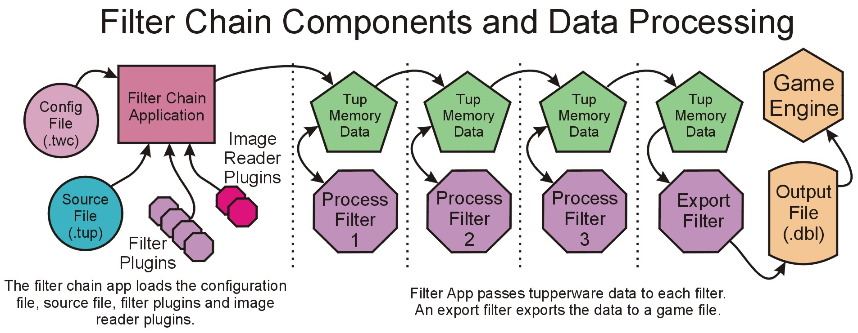
The following illustration shows the various components of the filter chain:

Filter Chain Application
This application connects all the pieces together. It is in charge of reading the source and configuration files as well as the plugins. It passes the Tupperware data from filter to filter. The Filter Chain Application is comprised of a command line and a GUI version. The command line version is able to override any options from the configuration file. The GUI version is used to easily provide input files and execute the Filter Chain on a single source file.

Filter Chain Configuration File
This file is a text file generated by the user. It outlines which filters are to be run, in which order as well as options for these filters. Each game and platform would have its own configuration file. Which configuration file the application will load is passed as a command line option.

Source Tupperware File
This is the data to run through the filter chain. This file is exported by the Tupperware exporter from Maya. Is loaded into memory before any of the filters are started.

Tupperware Memory Data
This is the data that runs through the filter chain. It is passed by pointer from one filter to another. If a filter needs to add additional data it may attach it anywhere within the Tupperware tree.

Filters Plugins
A filter plugin can manipulate the Tupperware Memory data as well as export the data to a file. These plugins are DLLs and are loaded by the Filter Chain Application at run time. A Manipulation filter usually will process the data and add new data within the database. An Export filter usually sits as the last filter in the chain and will export the data to the correct format. There is no difference between the two filters except in what they choose to do. Every filter may manipulate the Tupperware data. They may also export data. It is up to the filter programmer to determine what the given filter will do. Following is a list of currently used filters and a brief summary as to their purpose:

Annotate
This filter does the majority of the markup needed for the other filters.

Bounding
This filter computes the bounding information for the meshes and instances.

Break Large Meshes
This filter will cut up terrain meshes that are too big or belong in more than one visibility set into smaller meshes to aid with frame rate issues.

RealtimeLighting
This filter will cut up terrain meshes that have been partially marked for being realtime lit.

Cineman
This filter is used for generating files for real time cinematics

ExportPC- ExportPS2- ExportGCN- ExportXBOX
These filters are used for generating the platform specific data files need for the game engine. They rely on data from the other filters to accomplish this.

ObjectAttributes
This filter exports the attributes for the instances along with the attribute tree for access in the game engine.

MultiTex
This filter deals with the various multitexturing methods supported by the source artwork and puts this data in a format that the engine can deal with.

TriStrip
This filter computes and sorts the triangle strips and adds markup data for the export filters.

MakeYUp
This filter converts any data that was exported using a coordinate system that is z-up to one that is y-up (like the engine)

OBBWorld
This filter computes and exports collision data using Object Aligned Bounding Boxes.

DrOctopus
This filter computes and exports triangle based collision data.

Image Reader Plugins
An image reader plugin is used for accessing the various texture file formats. The Filter Chain Application will automatically search for these plugins and call their GetImageData function when a file needs to be loaded. The plugin will then attempt to read the file and convert it into a Tupperware tree. This tree is passed to the application and is available to any of the filter plugins. Currently there is only one Image Reader Plugin at this time, the Collage filter. The Collage filter is able to read any of the currently used image formats and provide this information to the other filters.

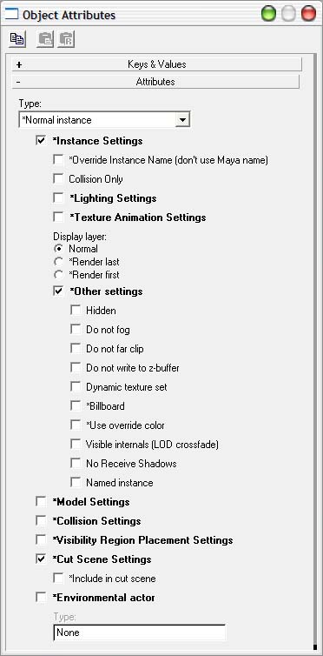
Attribute Tools
The attribute system allows for custom data to be added to instances, mesh faces, and material maps within Maya. The three Maya plugins that work to accomplish this are ObjAttrib, FaceAttrib, and MapAttrib respectively. Each uses a .cfg file that specifies the hierarchal attribute structure to be used. This attribute structure allows for child/parent attributes. When a checkbox is checked for example, a keyname and value strings are added to a text buffer for the selected instance. The default settings are retrieved from the config file so a key-value pair does not need to be added unless it deviates from the default.
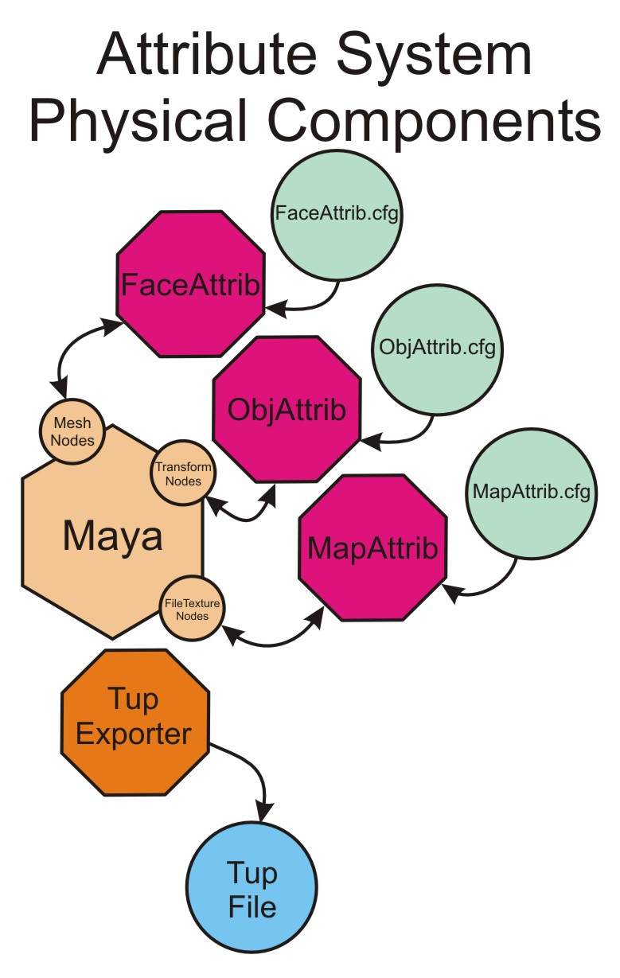
When exported to a Tupperware file the attribute texture buffers as well as the contents of the .cfg files are included in the output file. The FilterChain has access to the attributes through the use of the TupperAttrib Library. The game engine also has access to this data as well.
This system provides flexible system that allows the number of attributes to grow during the project without causing problems.

